JAVA 3 PROJECT Q3

30003389 – Kyer Potts

Table of Contents

# Debugging

Found Issue when compiling

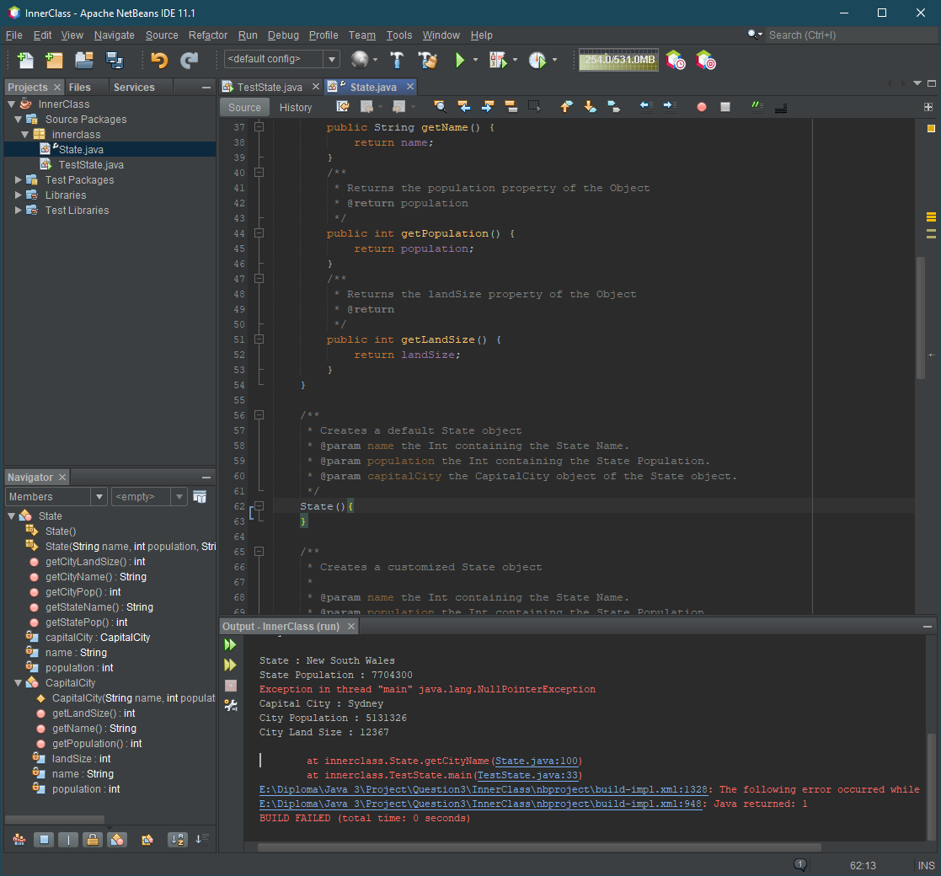

State constructor was not initialising default properties for the State object

Added default properties to State constructor

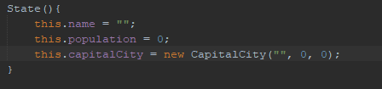

# Testing

|  |  |  |  |
| --- | --- | --- | --- |
| Test ID | Description | Outcome | Evidence |
| 1 | Create TAS object | Generates TAS object |  |
| 2 | Create VIC object | Generates VIC object |  |
| 3 | Create QLD object | Generates QLD object |  |

# Profiler

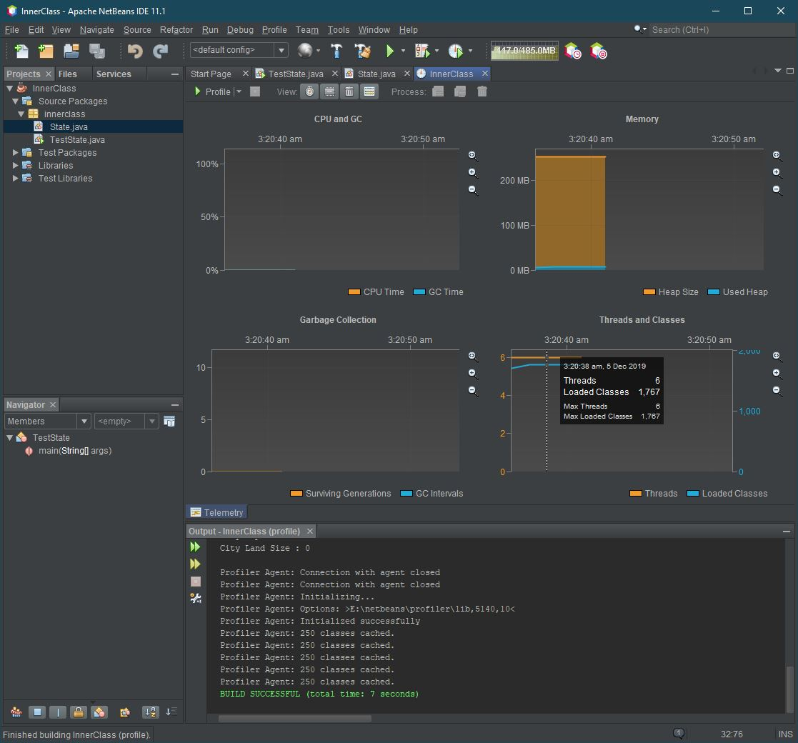

# JavaDoc

